Registered Student Organization Logo Policy
Updated March 7, 2018

Logo Usage: RSOs are allowed two options for logos:

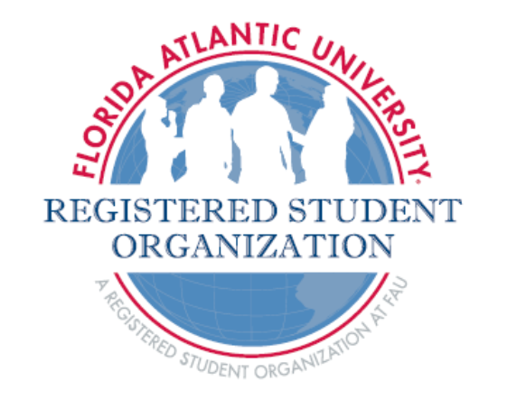
1. Use the standard logo available to FAU RSOs. This logo may not be altered and must appear as shown below or as shown in the Student Organization Style Guide. You can request the title of your student organization be added to this logo by emailing involvement@fau.edu. Requests will be sent by Student Activities and Involvement once a month, on the first business day of every month. The typical amount of time for logo creation is two to three weeks.

2. Create your own RSO logo that does not infringe upon existing FAU trademarks, such as the name of the University or its logos, institutional marks or spirit marks. Florida Atlantic University has registered or otherwise protected the names, logos, symbols, indicia, insignia, trade names, service marks and trademarks (collectively “Trademarks”) of the University and its related programs and entities. The letters or words “FAU,” “Florida Atlantic University,” “Florida Atlantic,” FAU Owls, Florida Atlantic University Owls or Florida Atlantic Owls may not be included in the logo. The RSO logo must include the statement “A Registered Student Organization at FAU®”. Please note that the Registered Trademark designation is included after the word FAU. All logos must be approved by Student Activities and Involvement and should be emailed to involvement@fau.edu . The typical amount of time needed for approving logos is between two and three weeks.

Other Cases for Logo Usage:

3. Organizations with national affiliation, such as Dance Marathon and Habitat for Humanity, may use the nationally recognized and trademarked logo with FAU mentioned, as long as it is sent to involvement@fau.edu for approval prior to any use.

4. Sport Clubs: Sport Clubs that are advised by the Department of Campus Recreation and recognized by the Sports Club Council may use the FAU spirit marks on uniforms and related gear when participating in league competition and must include an identifying statement adjacent such as Club Hockey, Rugby Club, etc. See the process below for ordering promotional items.

FAU Logo Use by Registered Student Organizations

FAU Logo Use: Registered student organizations may use FAU spirit marks and academic marks as approved by the Institution Art Sheet in their promotional items with proper approvals, as outlined below, but may not include any FAU marks in their individual organization logo creation as specified in 2 above.

Publications: Student Activities and Involvement must approve all publications (brochures, posters, etc.) that bear the FAU name or trademark prior to printing. Email involvement@fau.edu with your publication to request this approval.

Promotional Items: All promotional items (t-shirts, mugs, pens, etc.) ordered by an RSO must be ordered through an approved “Licensee,” regardless of the source of funding. Visit this link for an up to date list of vendors: FAU Licensee List. When you are using a “Licensee,” they will contact FAU directly to get approval.

Print, Radio, Television and Web Advertising: The Office of University Communications is responsible for reviewing and approving all advertising mediums for use of a trademark in print, radio, television and web advertising and will consult with Office of Marketing & Trademark Licensing, prior to public release. The Office of University Communications can also assist with media buying and marketing plans for large events/programs. Please email involvement@fau.edu or a staff member in the Student Activities and Involvement office on your campus for assistance.

